
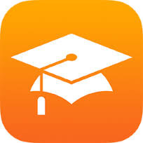
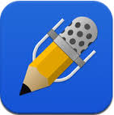
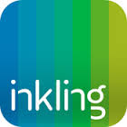
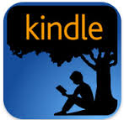

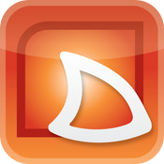
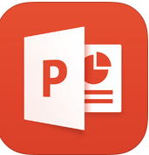
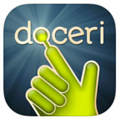
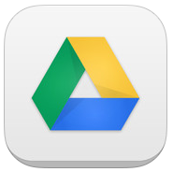
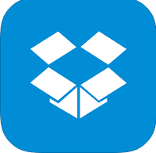
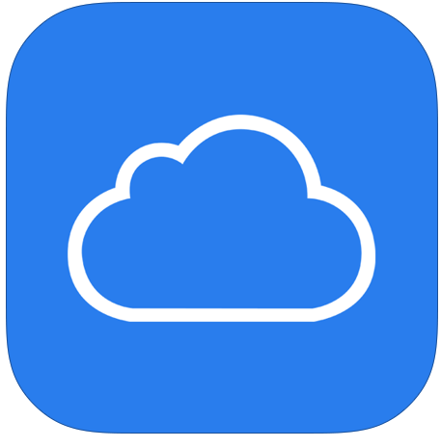
Inkling is best described as the publisher of smarts medical texts. These are E-Books only, but they make all of the photos and exercises interactive, which allows students to engage multiple different sensory mechanisms to learn the material more quickly and retain it longer. For example you can have 3D pop-out, or audio clips to enhance the material. (FREE, Texts Purchased separately)
PowerPoint and Slide Shark: Slide Shark allows you to present any PowerPoint using your iPad only. PowerPoint is a new app for the iPad but will allow you to present, modify create PowerPoint just as you would do on your desktop. (Free with Additional Subscription for added functionality PPT)
Doceri is the king or queen of virtual whiteboards. It is a remote control for your computer, allows annotation of slides and whiteboard options. It will also record your entire lecture for later review. (app is free, but desk top system integration is 30.00) (we saw enough value in this we will pay for it for our faculty that use it. )
Cloud Storage IS a must and allows students to access material at anytime any where on any device. Parameters can be set up so that each time you log out it is automatically synced to save your precious notes and lecture materials. We had one student have her iPad stolen 6 months into our program. She was thrilled she had cloud storage, because she did loose any of the valuable data or notes.
Kindle Reader is a must have for anyone looking to become paperless. It provided access to a vast library of kindle books that can all be downloaded or saved on the cloud for access anytime and anywhere where web access is available. Kindle versions of virtually all texts allows you to put 30-40 texts on an iPad that weighs about 1/6 of the normal anatomy texts. (FREE, Texts Purchased separately)
iAnnotate is similar to notability with a few added features. It very functional and well thought out. Most of our students prefer notability simply as a result of the price. (9.99)
Notability is one of the most essential apps for student and teacher in a classroom setting. It is a program that allows you to annotate, make notes, highlight and organize slides and documents. It plays well with all storage companies, and is very user friendly. FREE
iTunes U is a beautiful and elegant course management system optimized for iOS devices. It does very well with content delivery, but it is missing a few features that larger system may have available. FREE
Blackboard is a well renowned course management system. They have recently developed APP based tools to allow better navigation on mobile devices. Blackboard has tools for many different learning activities and is relatively ubiquitous in higher education. FREE for Registered institutions
There is an APP for that…

